Terraform Task -03

Overall Task Title
Terraform Execution and Jenkins CI Integration Using Maven and Parameterized Pipelines
Objective
- To understand and execute Terraform scripts demonstrated in the Terraform-03 video.
- To integrate Terraform with Jenkins using the Terraform plugin.
- To create a Jenkins Maven Project that:
  - Clones source code from GitHub
  - Compiles the application using Maven
- To create a Parameterized Jenkins Pipeline job using the same GitHub code.
- To understand and explain global variables in Jenkins.
Overall task Prerequisites
- Jenkins installed and running
- Java (JDK) installed on Jenkins server
- Maven installed and configured in Jenkins (Global Tool Configuration)
- Terraform installed or configured using Terraform Plugin
- Required Jenkins plugins installed:
  - Git Plugin
  - Maven Integration Plugin
  - Pipeline Plugin
  - Terraform Plugin
- GitHub repository access:
- https://github.com/betawins/java-Working-app.git
- Basic knowledge of:
  - Jenkins jobs
  - Maven
  - Terraform
  - CI/CD concepts

Execute the script shown in the video.
Terraform – Steps Performed
Step 1: Created Terraform Project
- Opened Visual Studio Code
- Created a folder named Terraform basic
- Inside the folder, created the following files:
  - main.tf
  - variables.tf
Step 2: Configured main.tf
- Added a local_file resource to create a text file
- Used variables for:
  - filename
  - content
- Added a random_pet resource to generate a random pet name
- Configured the following attributes:
  - prefix
  - separator
  - length
Step 3: Configured variables.tf
- Defined variable filename
  - Type: string
  - Description: File name for pets
- Defined variable content
  - Provided a default value (example: I love birds)
- Defined variable prefix
  - Provided a default value (example: hi)
Step 4: Initialized Terraform
- Opened PowerShell terminal in the project directory
- Executed the command:
- terraform init
- Terraform downloaded required providers:
  - local
  - random
- Terraform created:
  - .terraform directory
  - .terraform.lock.hcl
Step 5: Executed Terraform Apply (Default Values)
- Ran the command:
- terraform apply
- Terraform displayed the execution plan
- Approved the execution by entering:
- yes
Step 6: Verified Resource Creation
- Terraform created the following files automatically:
  - terraform.tfstate
  - terraform.tfstate.backup
- A file named Animals.txt was created in the project directory
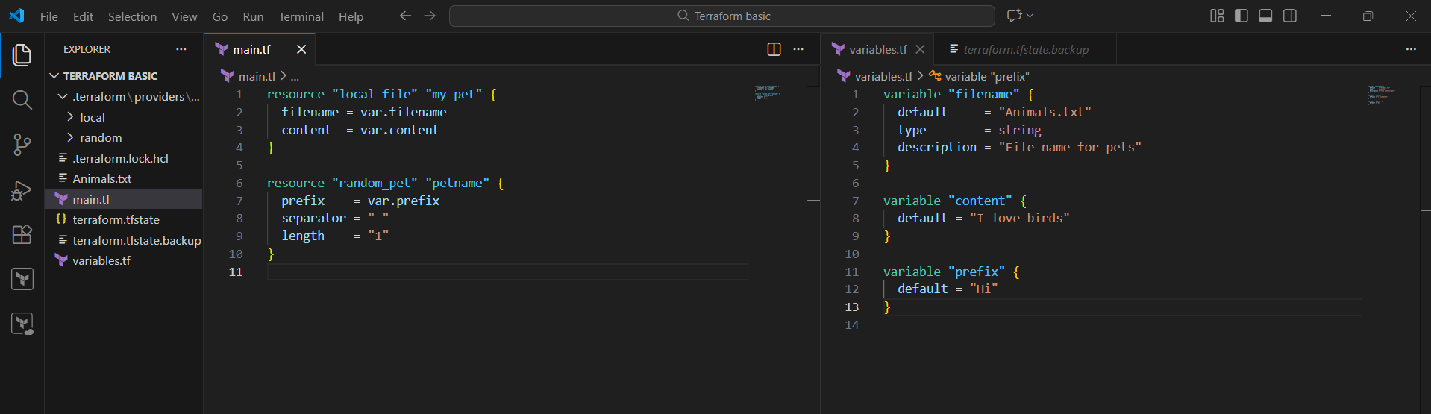
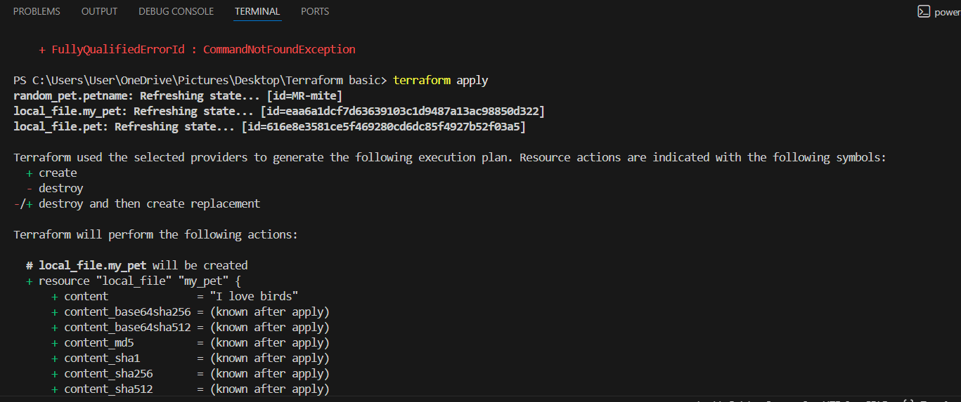
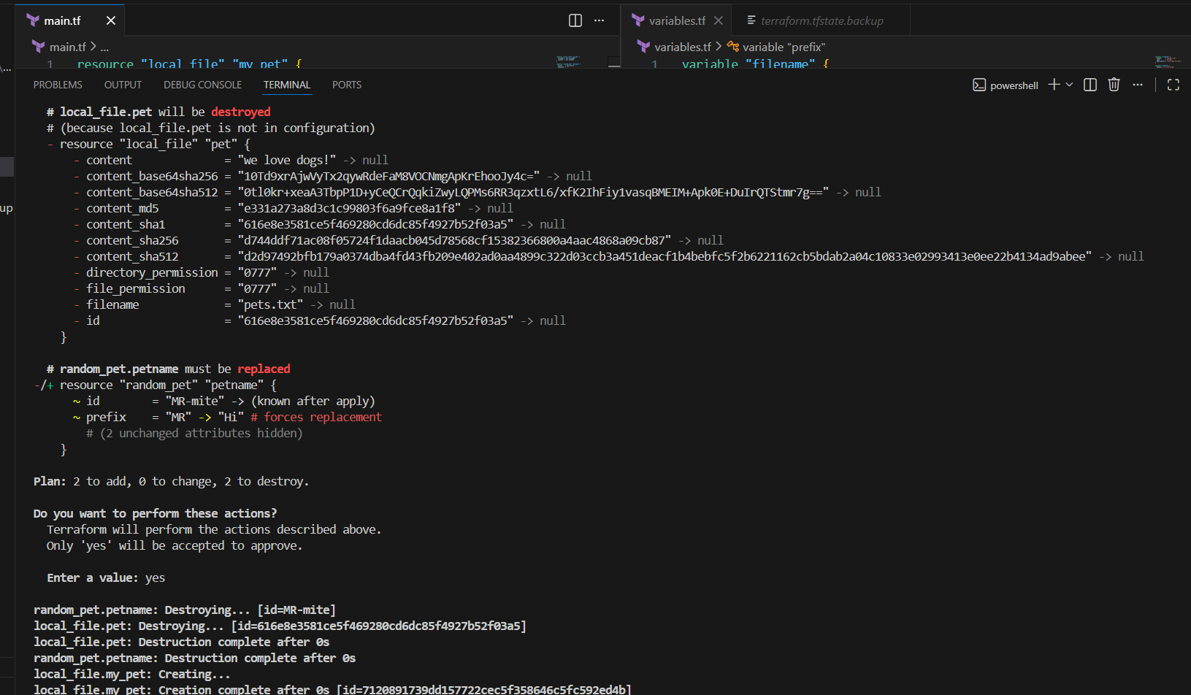
Step 7: Verified File Content
- Opened Animals.txt in VS Code
- Verified the content: I love birds
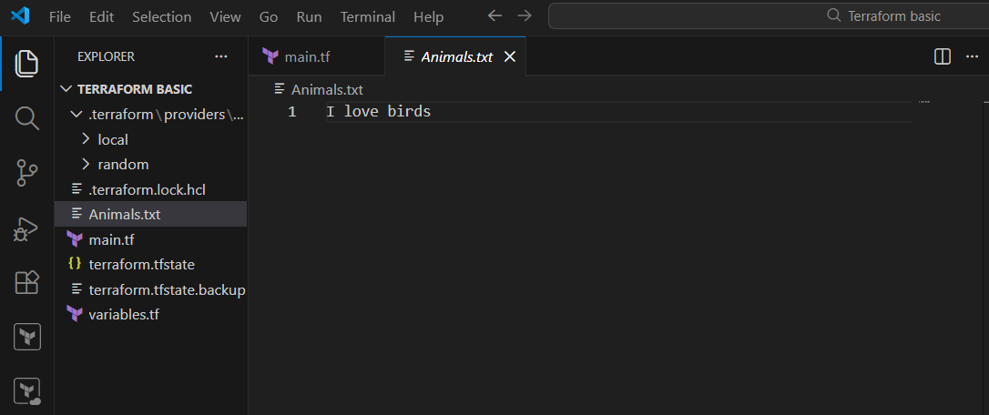
Step 8: Modified Variable Definitions
- Removed default values from:
  - content
  - prefix
- Saved the variables.tf file
- This change forced Terraform to request values during execution
Step 9: Executed Terraform Apply (Manual Input)
- Ran the command again:
- terraform apply
- Terraform prompted for variable values
- Entered values manually:
  - content → I love zebra
  - prefix → hello
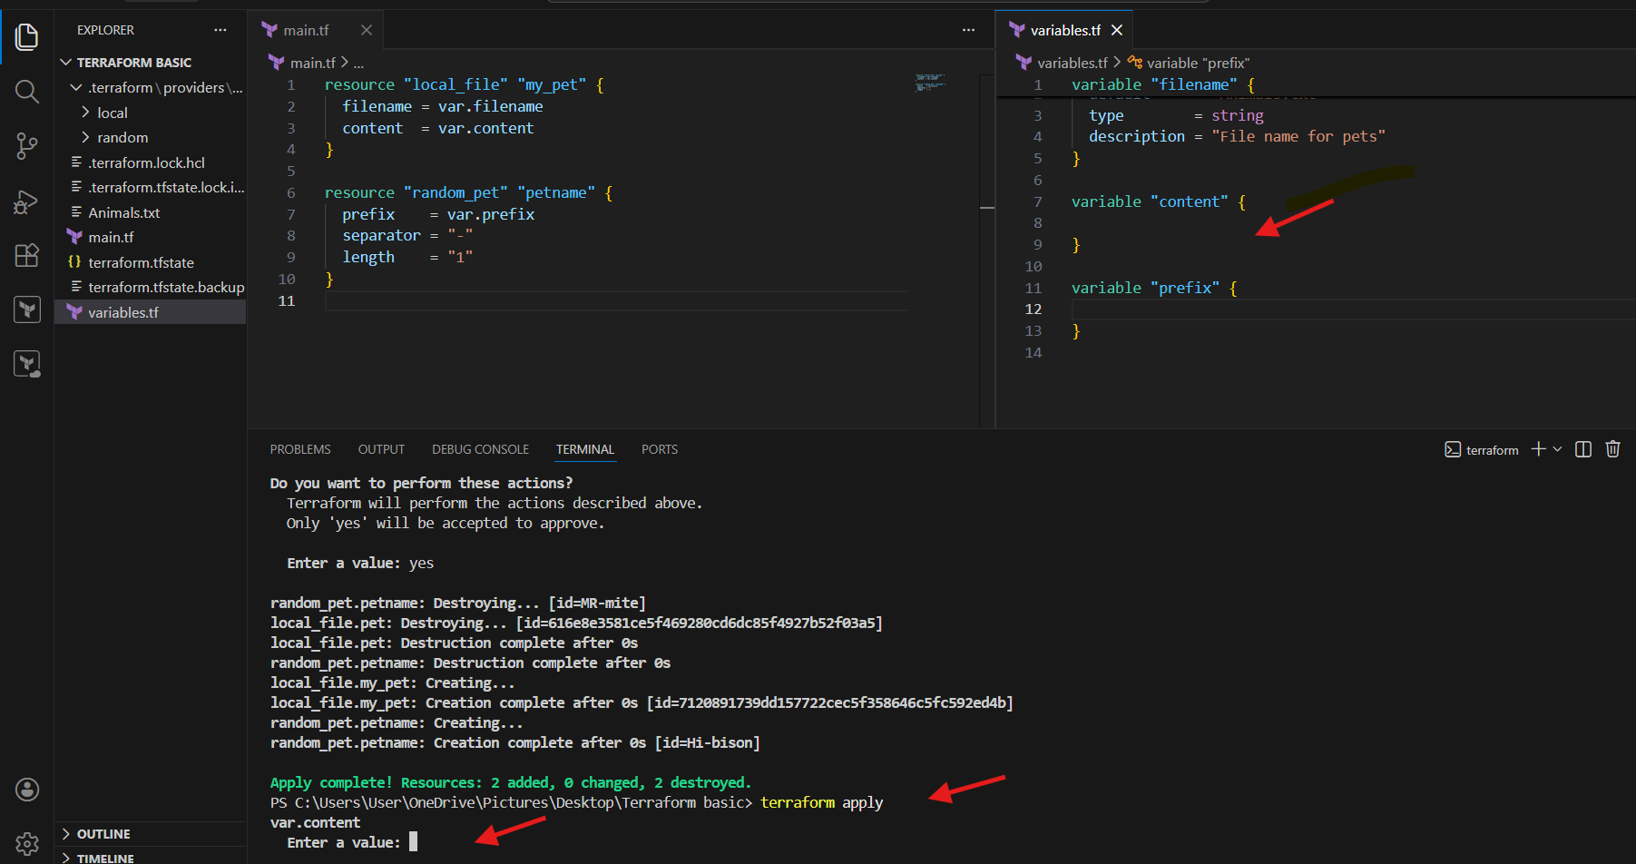
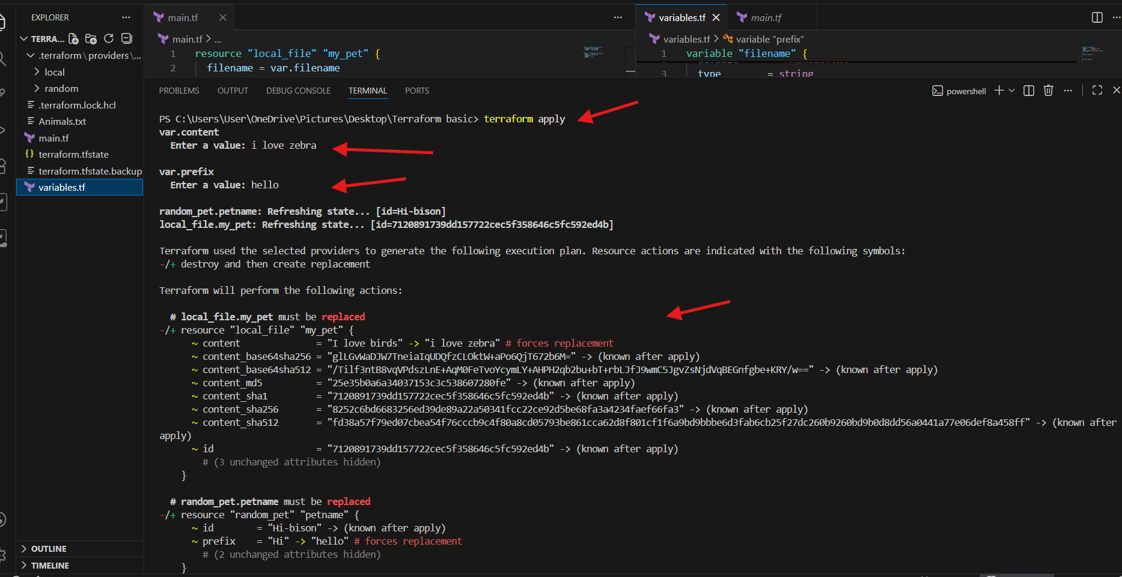
Step 10: Reviewed Terraform Plan
- Terraform detected changes and marked resources for replacement:
  - local_file.my_pet
  - random_pet. petname
- Reason:
  - Change in variable values forces resource recreation
Step 11: Approved Changes
- Confirmed execution by typing:
- yes
- Terraform destroyed old resources
- Terraform created new resources with updated values
Step 12: Verified Updated Output
- Opened Animals.txt
- Confirmed updated content:
- I love zebra
- Terminal displayed successful apply message indicating resources were recreated
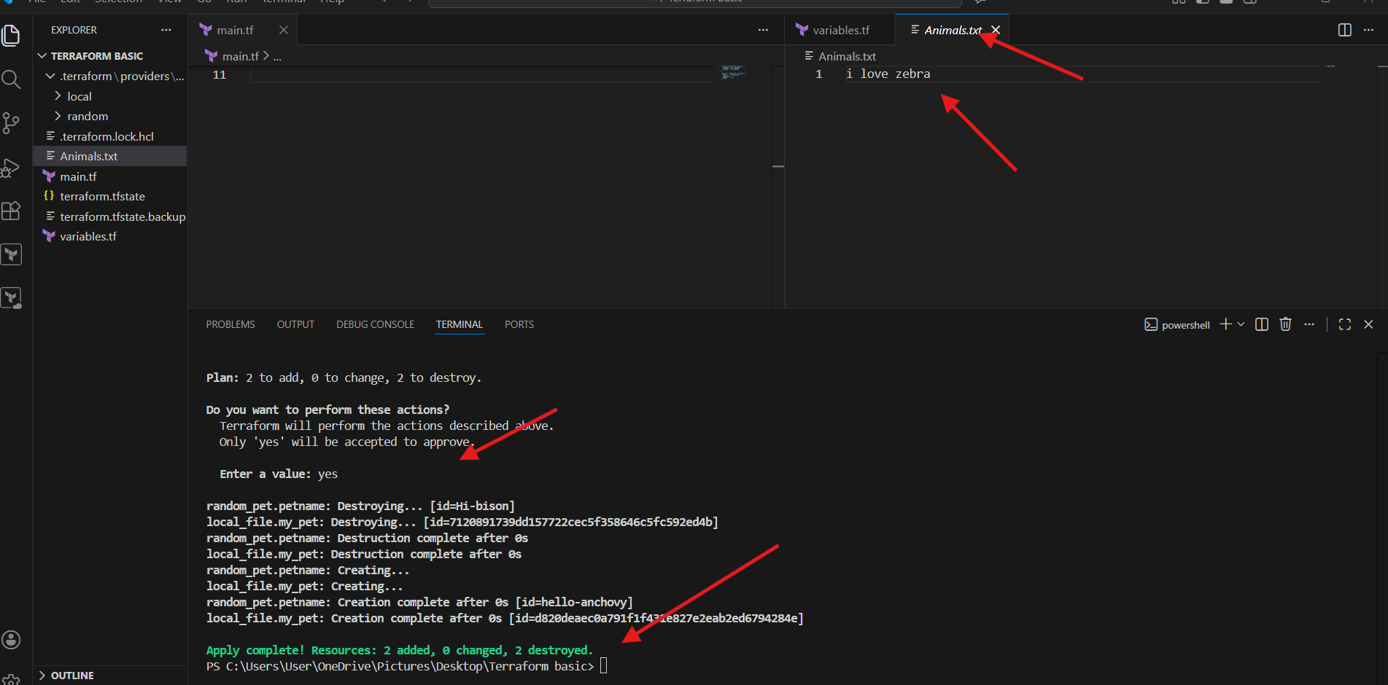
Step 13: Applied Terraform Using Inline Variable Values
- Opened PowerShell terminal inside the Terraform project
- Executed Terraform apply with inline variables:
- terraform apply -var "filename=Animals.txt" -var "content=I hate Zebra" -var "prefix=hello"
- Terraform refreshed the existing state
- Terraform generated an execution plan
Step 14: Reviewed Terraform Execution Plan
- Observed that:
  - local_file.my_pet was marked for replacement
  - Change in filename and content forced recreation
- Terraform displayed the plan summary:
- Plan: 1 to add, 0 to change, 1 to destroy
Step 15: Approved Terraform Execution
- Entered:
- yes
- Terraform destroyed the existing local file resource
- Terraform created a new file with updated values
- Apply completed successfully
Step 16: Verified Updated File Content
- Opened Animals.txt in VS Code
- Verified the updated content: I hate Zebra
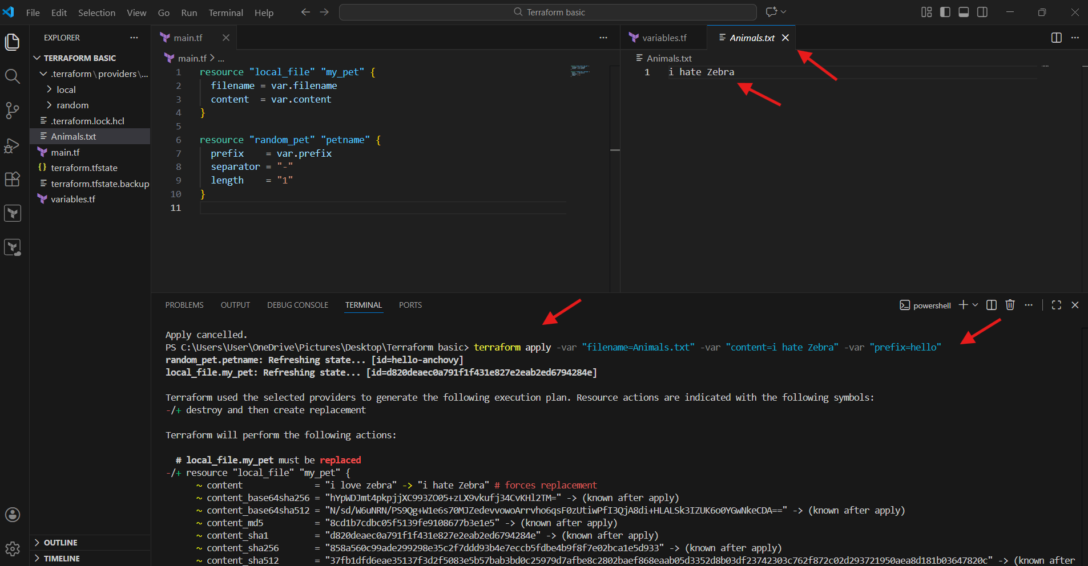

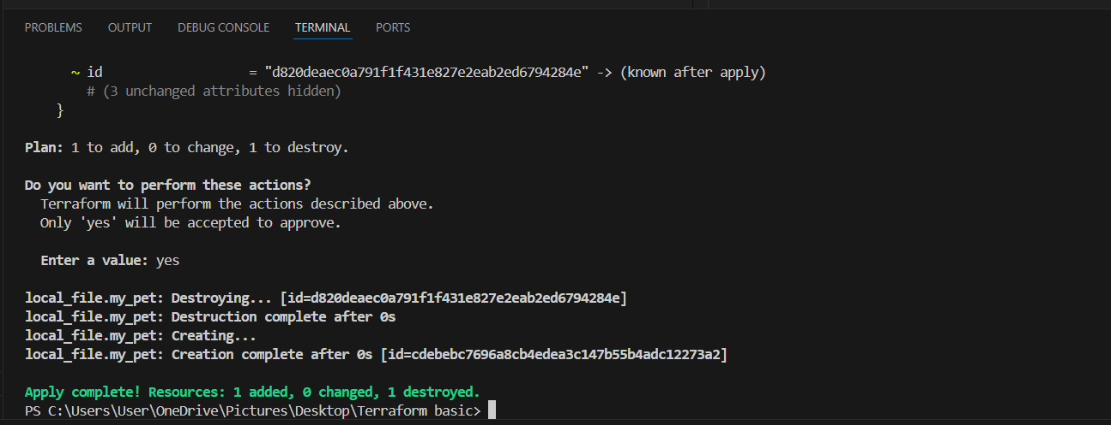
Step 17: Set Terraform Variables Using Environment Variables
- In PowerShell terminal, set Terraform variables:
- Set-Item -Path env:TF_VAR_filename -Value 'wild.txt'
- Set-Item -Path env:TF_VAR_content -Value 'I Love Dogs'
- Set-Item -Path env:TF_VAR_prefix -Value 'MISS'
Step 18: Executed Terraform Apply Using Environment Variables
- Ran the command:
- terraform apply
- Terraform detected changes due to updated variable values
- Both resources were marked for replacement
Step 19: Reviewed Replacement Plan
- Terraform displayed:
- Plan: 2 to add, 0 to change, 2 to destroy
- Confirmed that:
  - Local file
  - Random pet resource
would be recreated
Step 20: Approved Resource Replacement
- Entered:
- yes
- Terraform destroyed old resources
- Terraform created new resources with updated values
- Apply completed successfully
Step 21: Verified File and Random Pet Name
- Verified new file creation with updated filename
- Observed new random pet name generated with prefix MISS
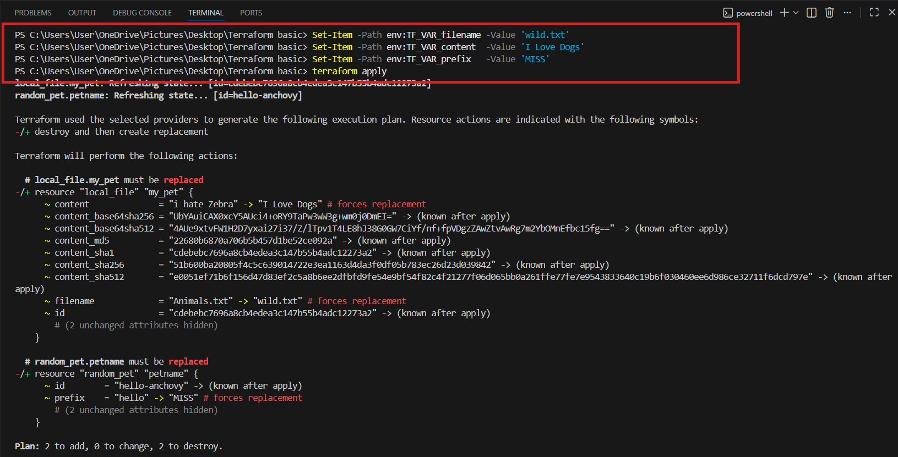
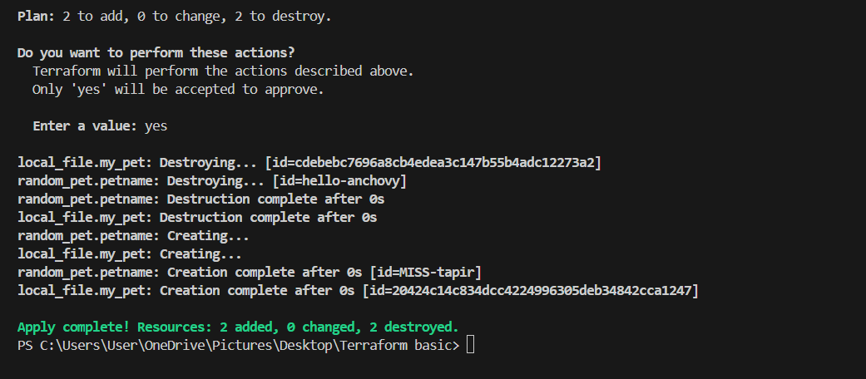
Step 22: Added Explicit Dependency in main.tf
- Updated main.tf to include:
  - depends_on for local_file.my_pet
- Ensured the local file depends on random_pet.petname
Step 23: Applied Terraform After Adding Dependency
- Executed:
- terraform apply
- Approved execution by typing:
- yes
- Terraform recreated resources in correct dependency order
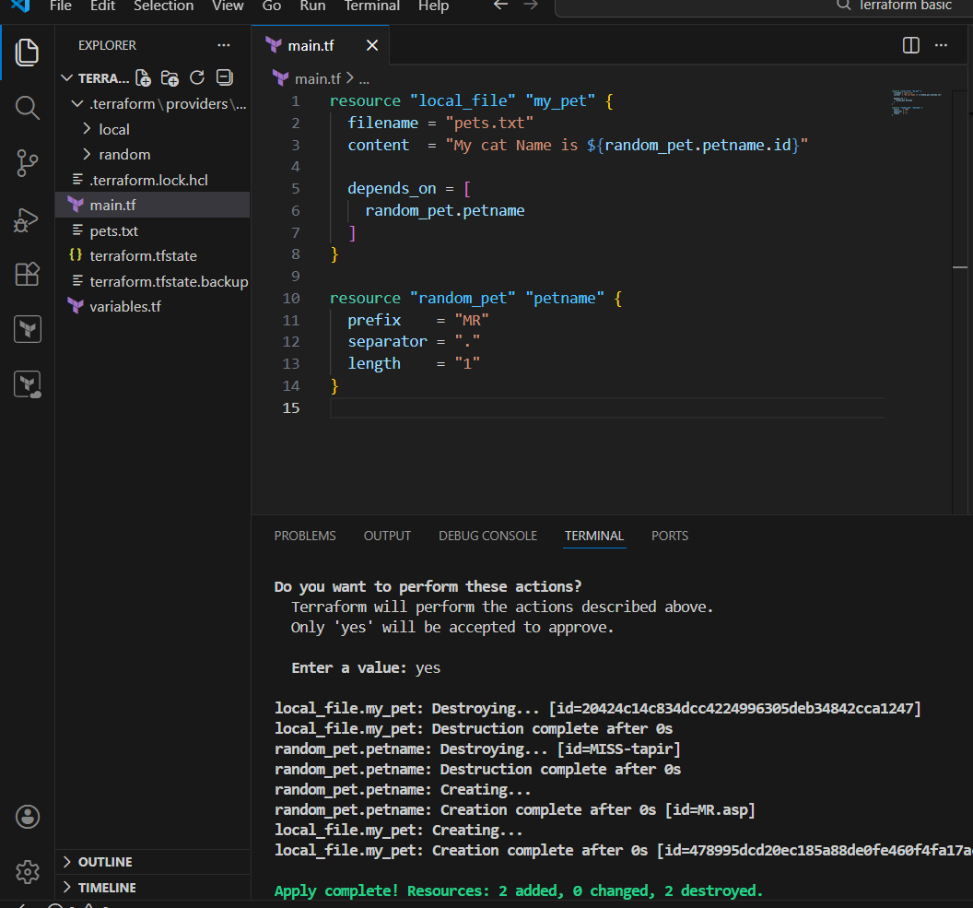
Step 24: Added Output Block
- Added the following output block in main.tf:
- output "pet_name" {
- value = random_pet.petname.id
- }
- Saved the file
Step 25: Applied Terraform to Update Output
- Ran:
- terraform apply
- Terraform detected only output changes
- Approved execution by typing:
- yes
- No resources were recreated
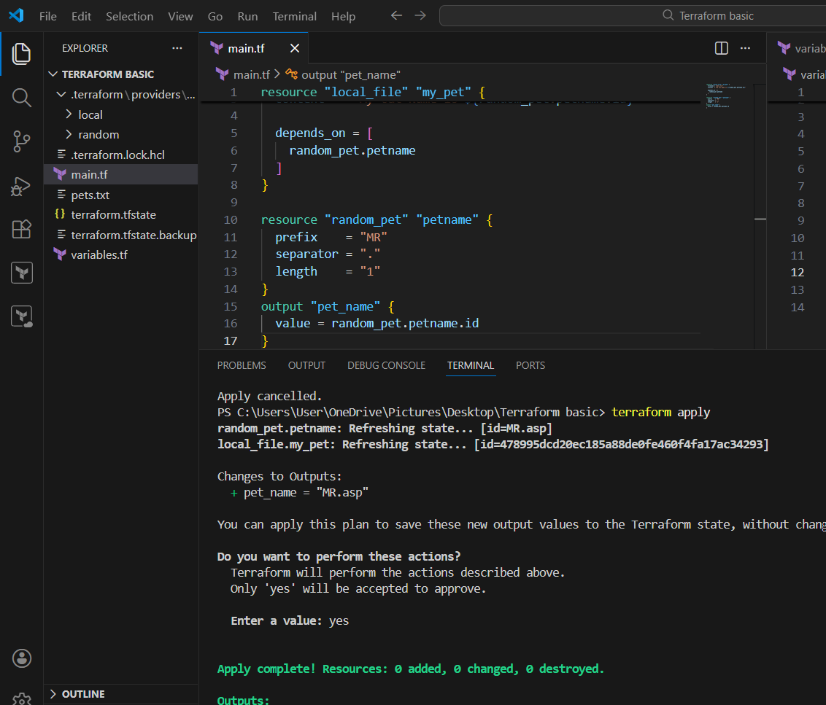
Step 26: Displayed Terraform Output
- Executed:
- terraform output
- Verified the output displayed:
- pet_name = "MR.asp"
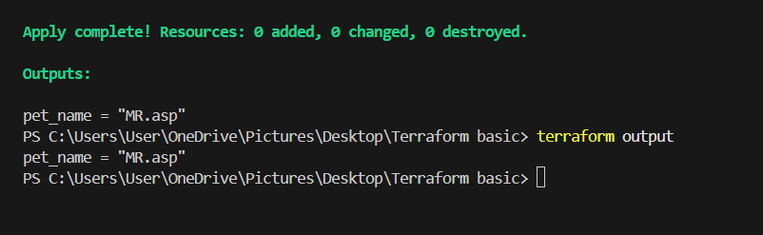

Integrate Terraform in Jenkins using the Terraform plugin.
- Create one Jenkins job using Maven Project for the code below with two stages:
- Stage 1: Git clone
Stage 2: Maven Compilation Code: https://github.com/betawins/java-Working-app.git
Jenkins Maven Project – Steps Performed
Step 1: Verified Terraform Plugin Installation
- Logged in to Jenkins Dashboard
- Navigated to:
- Manage Jenkins → Plugins → Installed Plugins
- Searched for Terraform
- Verified that Terraform Plugin is installed and enabled
Step 2: Configured Terraform Tool in Jenkins
- Navigated to:
- Manage Jenkins → Tools
- Clicked on Add Terraform
- Entered tool name as Terraform
- Enabled Install automatically
- Selected Terraform version from binary.com
- Clicked Save
Step 3: Installed Maven Integration Plugin
- Navigated to:
- Manage Jenkins → Plugins → Available Plugins
- Searched for Maven
- Selected Maven Integration Plugin
- Clicked Install
- Waited for plugin installation to complete
Step 4: Created a New Jenkins Job
- From Jenkins Dashboard, clicked New Item
- Entered job name as:
- Maven-project
- Selected Maven project
- Clicked OK
Step 5: Configured Git Repository in Jenkins Job
- Opened Maven-project → Configure
- Navigated to Source Code Management
- Selected Git
- Entered repository URL:
- https://github.com/betawins/java-Working-app.git
- Left credentials as none
- Under Branches to build, entered:
- */main
- Clicked Save
Step 6: Configured Build Triggers
- In job configuration, navigated to Triggers
- Enabled:
  - Build whenever a SNAPSHOT dependency is built
- Left other trigger options unchecked
Step 7: Configured Maven Build Settings
- Navigated to Build section
- Entered Root POM as:
- pom.xml
- Entered Goals and options as:
- clean compile
- Selected Run regardless of build result
- Clicked Save
Step 8: Executed the Jenkins Job
- Returned to Maven-project job page
- Clicked Build Now
- Observed a new build entry created under Build History
Step 9: Verified Build Execution
- Clicked on the latest build number
- Checked Console Output
- Verified:
  - Git repository cloned successfully
  - Maven build executed successfully
  - No build errors reported
Step 10: Confirmed Successful Build Status
- Observed green checkmark next to the build
- Verified build status as SUCCESS
- Checked Permalinks section:
  - Last build
  - Last successful build
  - Last completed build
Step 11: Verified Job Configuration
- Opened Configure again for Maven-project
- Confirmed:
  - SCM configuration
  - Triggers
  - Maven goals
- No changes required
Step 12: Validated End-to-End Flow
- Confirmed Jenkins performed the following actions:
  - Pulled source code from GitHub
  - Used Maven to compile the application
  - Completed build without errors
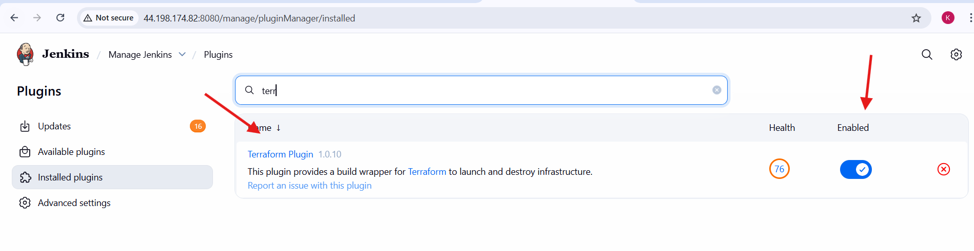
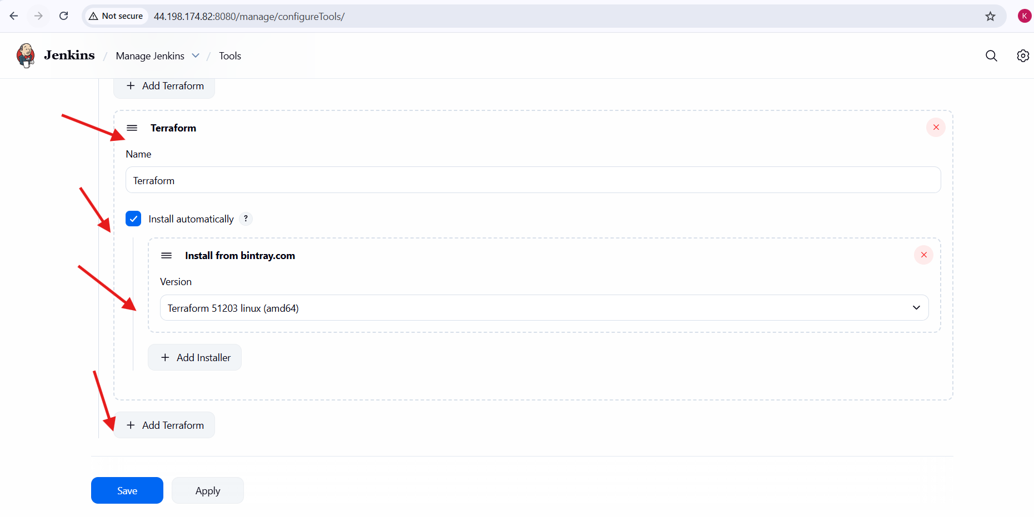
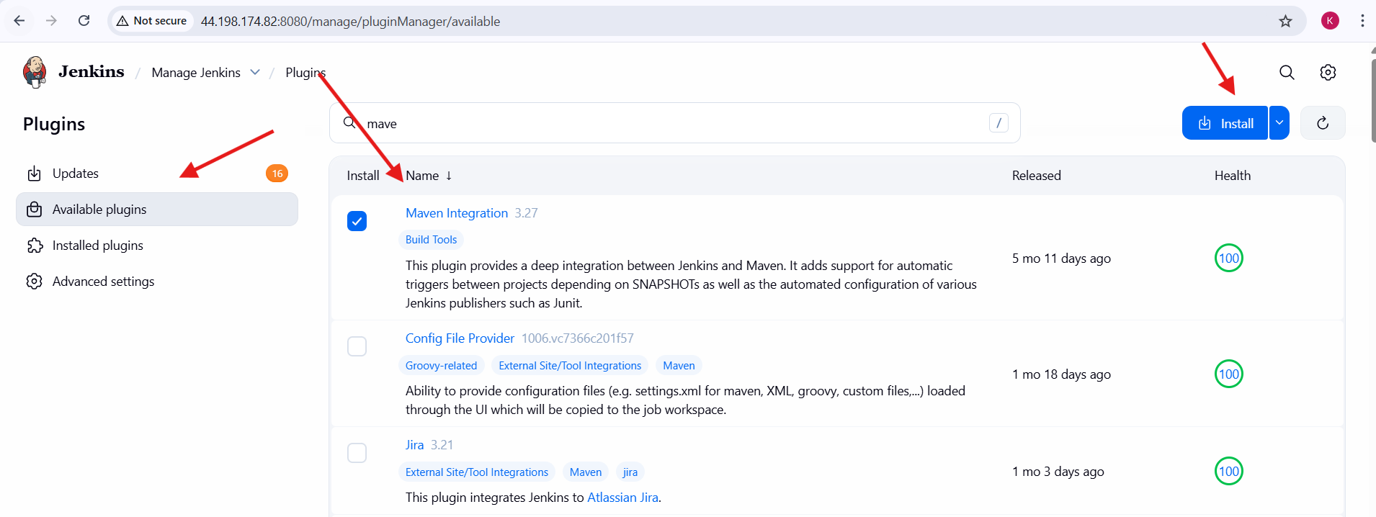
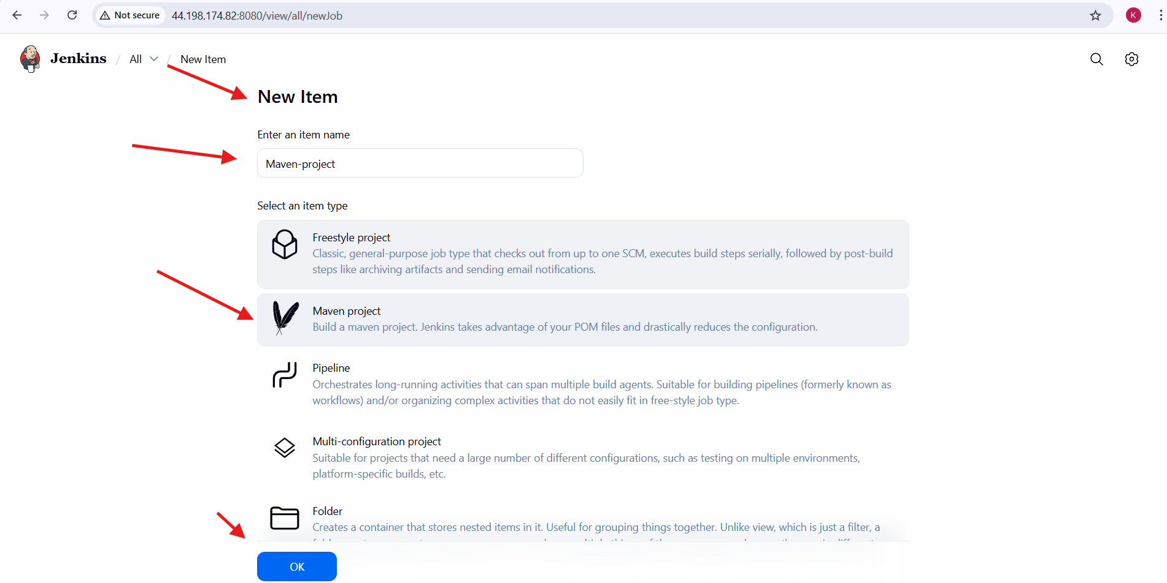
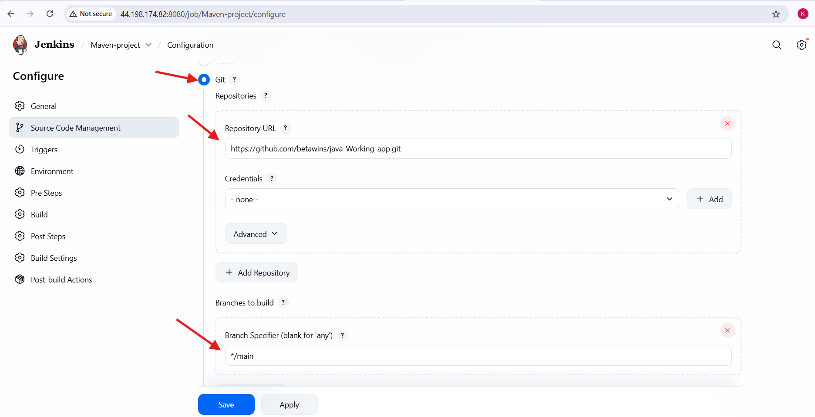
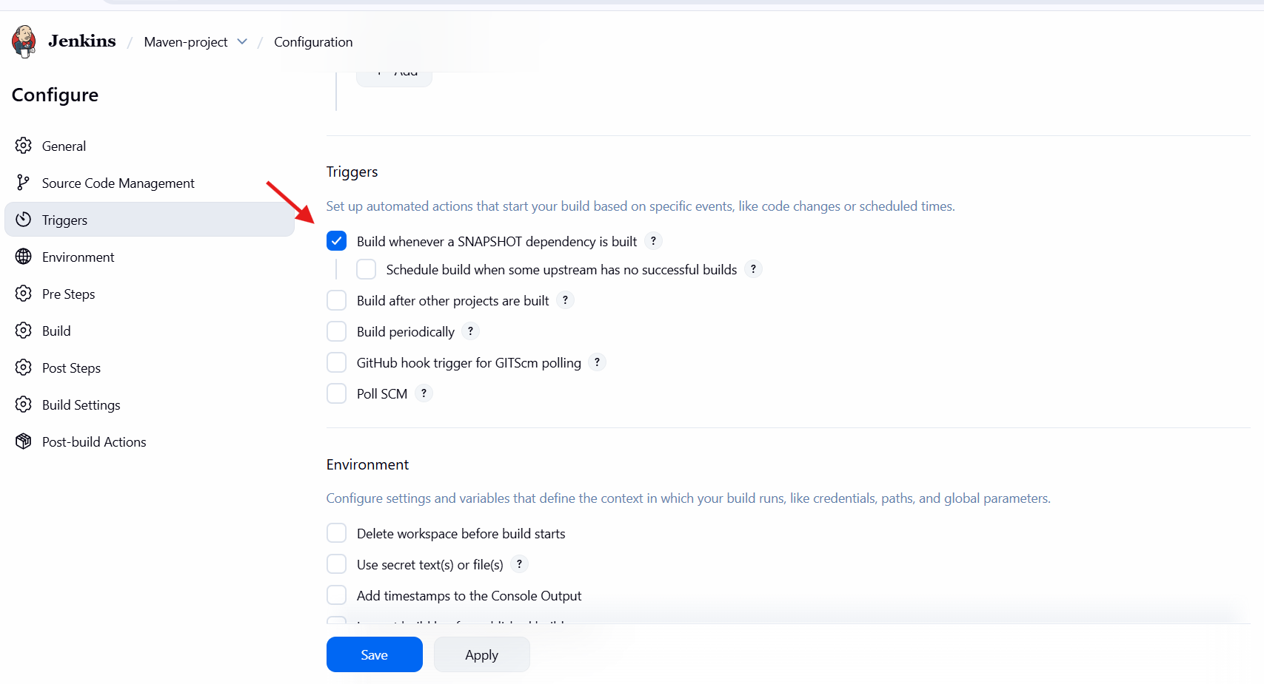
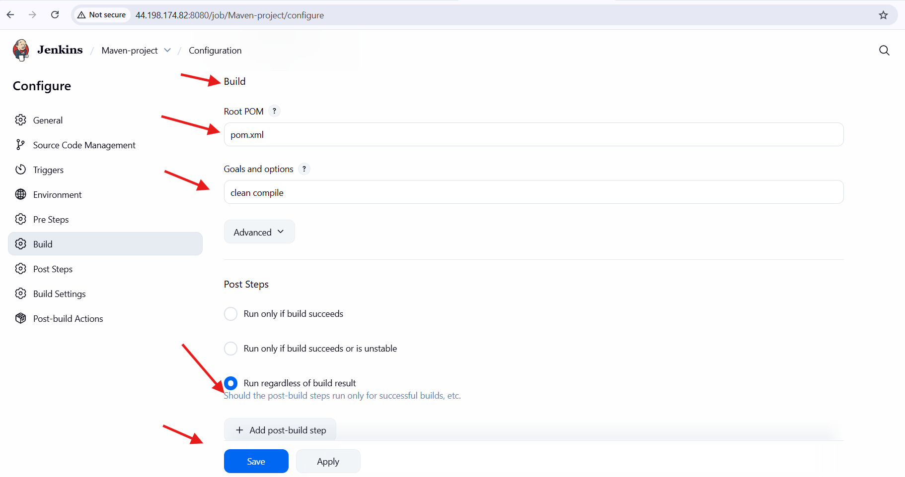
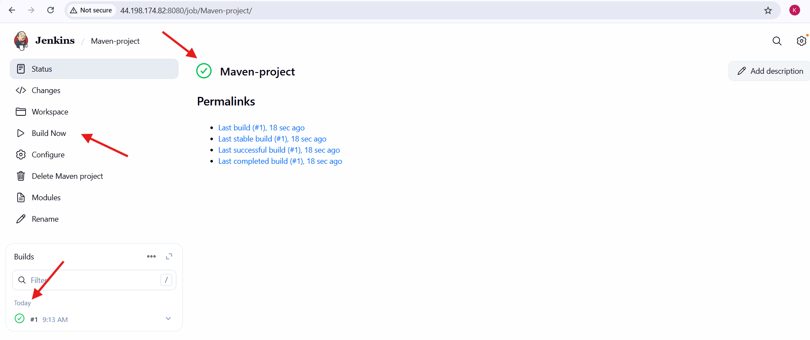

2.Use the same code and create a parameterized job in Jenkins with:
- Stage 1: Git clone
Stage 2: Maven Compilation Code: https://github.com/betawins/java-Working-app.git

Jenkins Parameterized Pipeline Job – Steps Performed
Step 1: Created a New Jenkins Pipeline Job
- Logged in to Jenkins Dashboard
- Clicked on New Item
- Entered the job name as:
- parameterized job-terraform task
- Selected Pipeline as the job type
- Clicked OK
Step 2: Enabled Job Parameterization
- Opened the job Configuration page
- Enabled the option:
- This project is parameterized
- Clicked on Add Parameter
- Selected String Parameter
Step 3: Added Git Repository Parameter
- Created a string parameter with the following details:
  - Name: Git_Repo
  - Default Value:
  - https://github.com/betawins/java-Working-app.git
  - Description: To clone source code from GitHub
Step 4: Added Branch Parameter
- Clicked Add Parameter
- Selected String Parameter
- Entered:
  - Name: BRANCH
  - Default Value: main
  - Description: git clone
Step 5: Added Maven Goal Parameter
- Clicked Add Parameter
- Selected String Parameter
- Entered:
  - Name: MVN_GOAL
  - Default Value:
  - clean compile
Step 6: Configured Pipeline Script
- Navigated to the Pipeline section
- Selected Pipeline script as the definition
- Entered the declarative pipeline script
- Pipeline included:
  - agent any
  - Maven tool configuration
  - Parameter definitions
  - Git clone stage
  - Maven compilation stage
- Enabled Use Groovy Sandbox
- Clicked Save
Step 7: Opened Build with Parameters
- From the job page, clicked Build with Parameters
- Jenkins displayed input fields for:
  - Git_Repo
  - BRANCH
  - MVN_GOAL
- Verified default values were populated
Step 8: Triggered the Parameterized Build
- Clicked the Build button
- Jenkins started the pipeline execution
- A new build entry was created under Build History
Step 9: Observed Pipeline Stage View
- Opened the Stage View
- Verified successful execution of stages:
  - Declarative Tool Install
  - Git Clone
  - Maven Compilation
- All stages completed successfully (green status)
Step 10: Verified Successful Build
- Observed green checkmark indicating SUCCESS
- Verified build number and execution time
- Checked Permalinks section:
  - Last build
  - Last successful build
  - Last completed build
Step 11: Confirmed End-to-End Flow
- Jenkins successfully:
  - Accepted user-defined parameters
  - Cloned the Git repository using provided branch
  - Executed Maven goals based on user input
  - Completed pipeline execution without errors
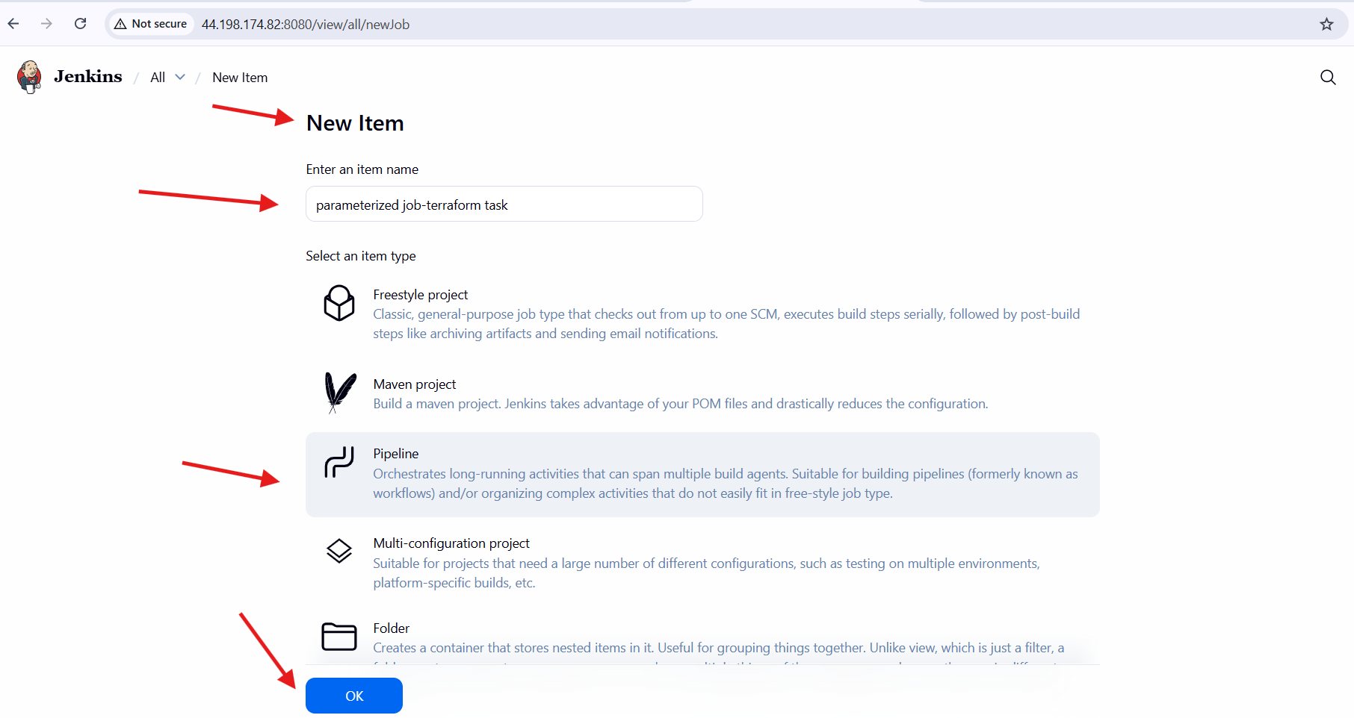
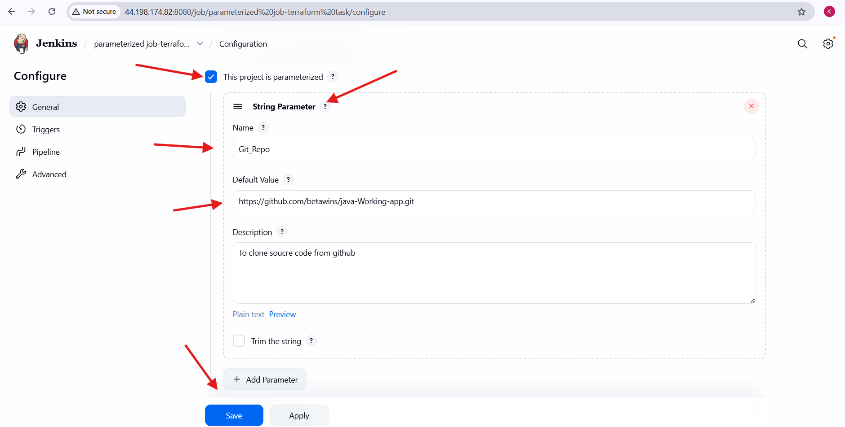
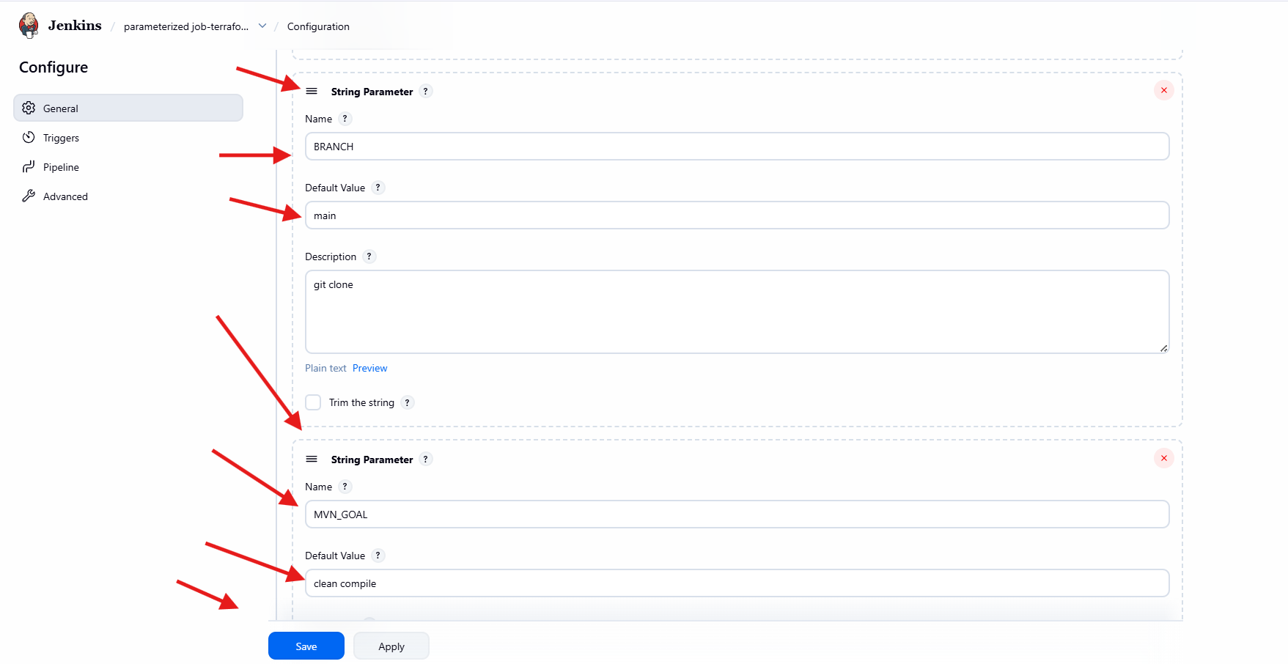
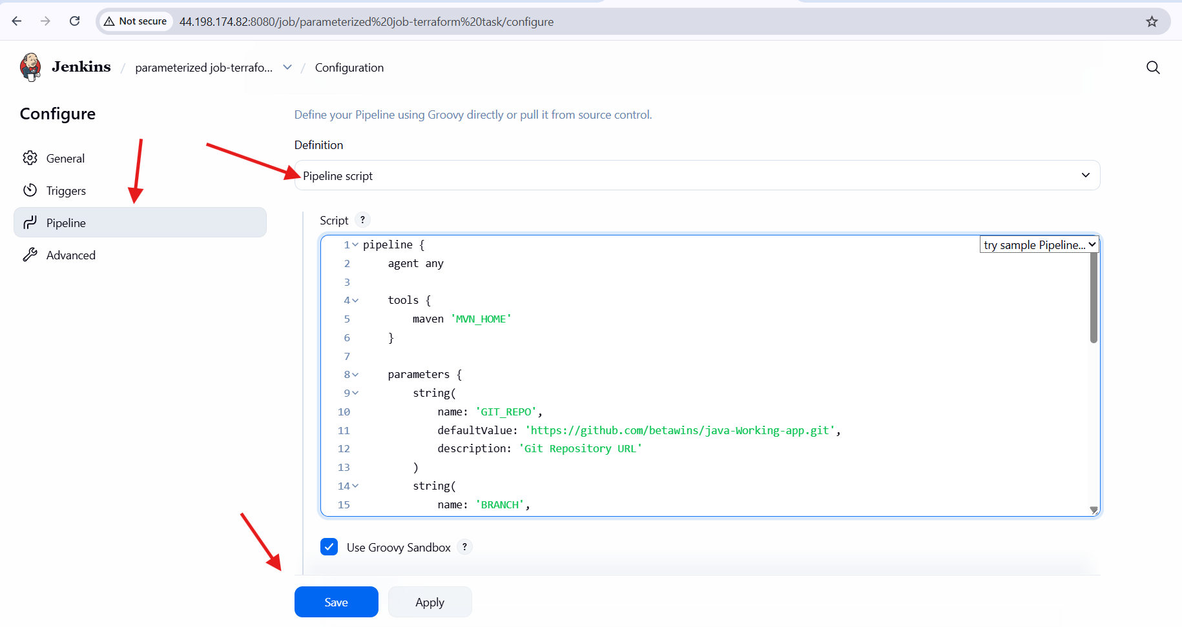
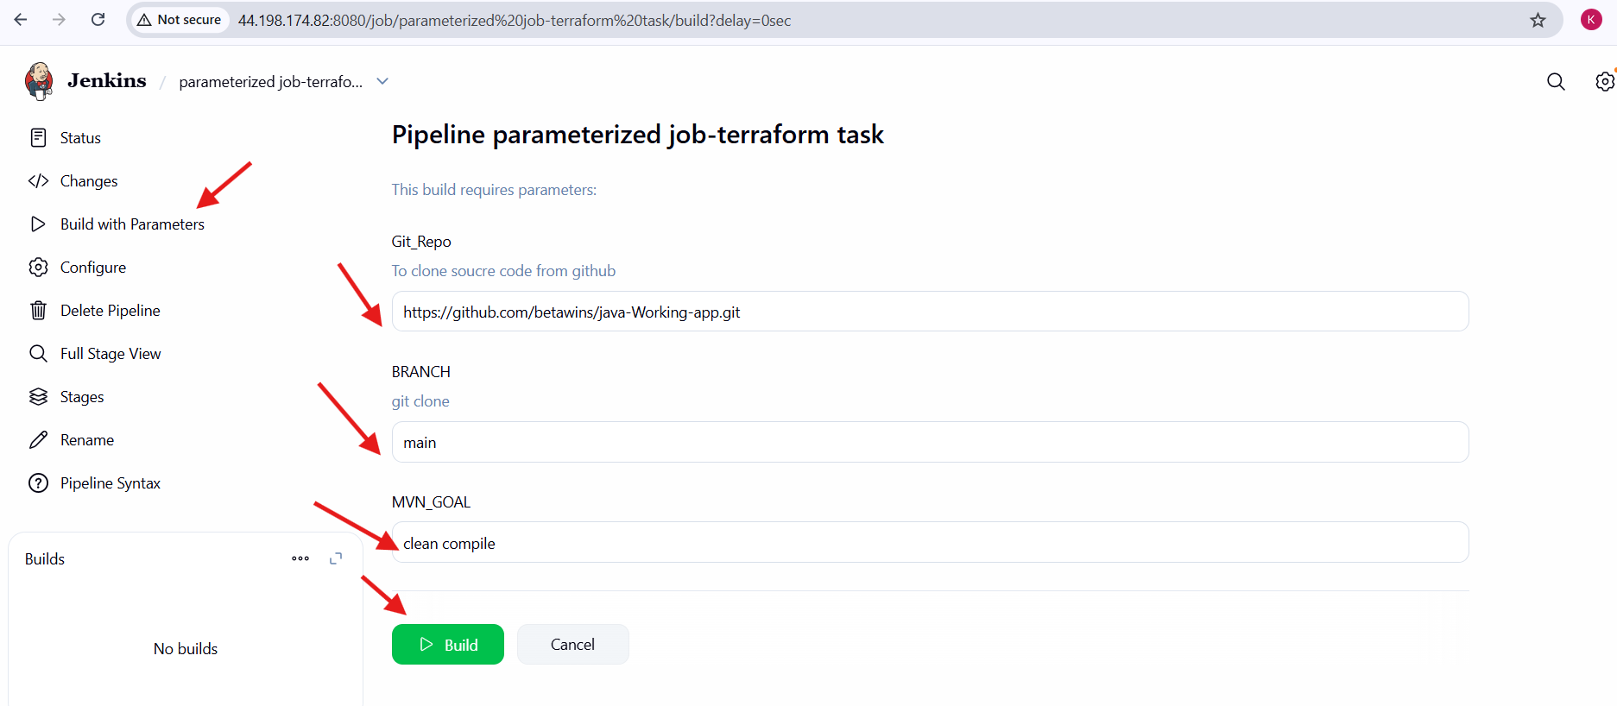
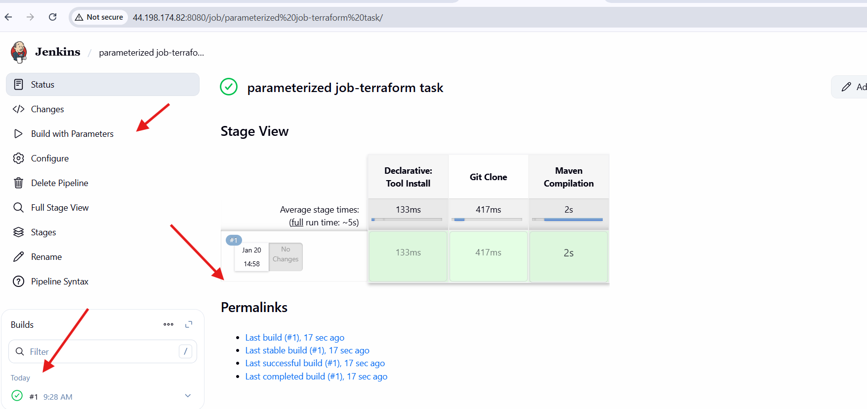

- What are the global variables in Jenkins?
- In Jenkins, global variables are the predefined variables that are available across the Jenkins pipeline to access job, build, and environment related information.
Common Jenkins global variables are:
- env → Gives access to environment variables like env.BUILD_NUMBER, env.JOB_NAME.
- params → Access parameters passed to the job like params.BRANCH, params.GIT_REPO.
- currentBuild → Provides current build details like currentBuild.result, currentBuild.number.
- scm → Refers to source code management configuration used in the pipeline.
- steps / sh / bat → Pipeline steps used to execute commands.
- node / workspace → Helps access agent node and workspace location.

Overall Task Conclusion:
- Successfully executed Terraform scripts as shown in the Terraform-03 video.
- Integrated Terraform with Jenkins using the Terraform plugin.
- Created a Jenkins Maven Project with:
  - Stage 1: Git Clone
  - Stage 2: Maven Compilation
- Created a Parameterized Jenkins Pipeline job using the same GitHub repository.
- Verified successful builds using Jenkins Stage View and Console Output.
- Gained understanding of Jenkins global variables and their usage in pipelines.

